Christmas Newsletter 2019

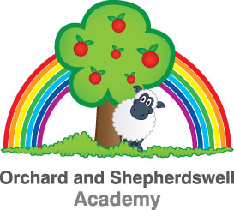
Dear Parents, Carers, Families and Children,
It has been a very busy half-term with so much going on at school – many staff members have commented that time has seemingly flown by! Speaking of which – this will, of course, be my last Newsletter of the decade, which is very hard to comprehend. We had to struggle through this half-term at times, particularly when we were hit badly by a ‘sickness bug.’ Thank you to parents and carers who supported us in this regard by not sending their children to school within 48 hours of their child being sick. It did help us get back to normal attendance levels quicker! I would also like to thank the staff here for all their hard work in keeping the school clean during that period – particularly the site staff and cleaners who spent a lot of time disinfecting surfaces likely to have been touched.
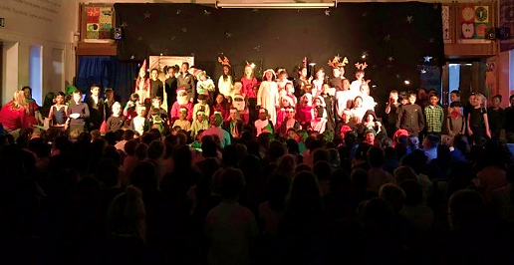
In spite of illnesses, there has been much to celebrate. The children, as always, have done so much for us all to be proud of. The Year 3 performance of “When Sasha got Swept up the Chimney” was a real highlight, particularly given the number of lines some children had to deliver and the number of songs they all needed to learn! There were also some really inspirational performances from children either singing solos or having to step into a part in place of an absent child with very little notice. Well done!
On reflection, then – it’s been a busy and challenging yet highly enjoyable half-term. I would very much like to take this opportunity to wish you and your families a Merry Christmas and a Happy New Year from everybody here at Orchard Academy.
Remembrance Parade
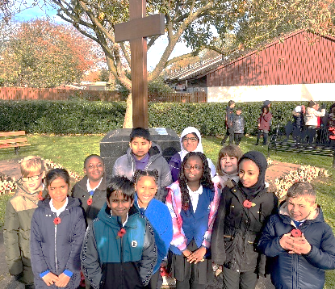
On 11th November, also known as Armistice Day, our school council (with children from Shepherdswell and local schools) took part in a remembrance parade at Coffee Hall. This was a poignant, moving event during which Shiba from our school council laid a wreath of remembrance as we paid tribute to those who have given their lives in conflict to protect our freedom. The children represented Orchard superbly and were rewarded with a drink and some cake (kindly provided by Woughton Community Council who organised the event). Orchard raised over £200 for the Royal British Legion through the sale of poppies and other remembrance items such as ‘snap-bands.’

The Orchard Reading Room
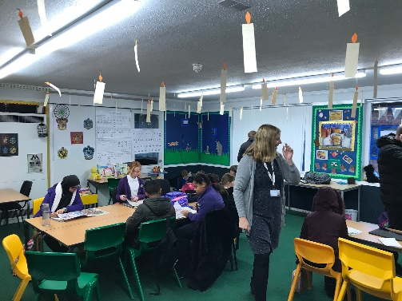
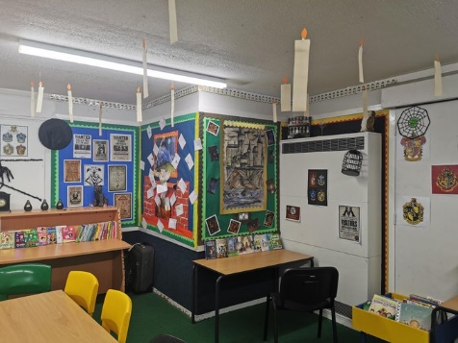
In our continued pursuit of trying to ensure every child at Orchard LOVES reading, we have this term unveiled our new lovely, colourful and cosy ‘Reading Room,’ located in the main school building near the walkway connecting the new building. Open most Tuesday, Thursday and Friday mornings before school, pupils and relatives are able to ‘pop in’ and enjoy a bit of reading time with a free hot drink. We would whole-heartedly encourage you to stop by and read with your children – if nothing else, it’s a great way to get out of the cold morning air at this time of year! Thank you very much to Mrs. Naylor who has been instrumental in getting the reading room up-and-running!
Social Media
Thank you so much to those who have ‘followed’ us and engaged with our social media accounts. If you haven’t already followed us – please do so! We are trying to improve the way we communicate with you, as well as showing off the amazing things that happen at Orchard all the time.

You can find us on Twitter @OrchardEMAT and on Facebook @OrchardAcademyMK.

Quality Pre-used Uniform
You may have noticed that at reception we have a pre-used uniform shop. This is made up of good-quality, donated uniform which is available to you for £1 or less. Please let reception know if you would like to come in to browse the available clothes!

Anti-Bullying
As part of National Anti-Bullying Week from the Anti-Bullying Alliance, we took part in ‘Odd Socks Day.’ The day sends an important message to people that they should be allowed to be themselves, free from bullying, and helps us celebrate Anti-Bullying Week in a fun and positive way. Thank you to everyone who supported this event, and thank you to all the children who have applied to be an Anti-Bullying Ambassador!

Car Parking at School
We know that many of you do park safely and sensibly and thank you for this. I always use newsletters to remind parents and carers to please park sensibly and courteously. This means:
- Parking within the lines of the marked bays at the front of school – and using these marked bays if they are available
- Being patient, respectful and courteous to other road users, setting a positive example to our children
- NOT parking on the pavement at the front of school. We recently had families unable to walk on the pavement out of school because an inconsiderate driver had parked so far across it – blocking anyone from getting through
- NOT parking in the unmarked areas at the end of the bays close to the Fishermead Bridge. This area is designed as a turning-circle to allow people to turn their cars around if there are no spaces available. If you park in the turning circle, you will stop yourself and many others from being able to leave the parking area at the front of school
- NOT parking on double-yellow lines, in the ambulance bay on Ravensbourne Place or in front of our neighbours’ driveways.
Today we have had a collision between a moving-car and a parked-car because of a parent driving into the staff car park at the rear of school. This is not the first collision in our car park, and concerns me greatly because the parked-car could have been a child. Therefore, we will be closing the gates to the staff car park at drop-off times. Please be reminded that parents and children accessing the rear school-gate on Ravensbourne Place should come into school using the pavement – not walking on the road or through the car park which is clearly dangerous.
Academy Staffing
It is with a great deal of sadness that we say goodbye to three staff members today, and ‘au revoir’ to one other.
We wish all the best to Miss Abigail Borg, who has been at Orchard since 2015. Miss Borg has been an integral part of the Year 3 team in her time here and is always popular with her classes because of her kind nature, high expectations and strong aspirations for her pupils. During Miss Borg’s time at Orchard, she has truly taken to heart and been a fundamental part of our family ethos. She will be sorely missed by staff as well as pupils in Yew class.
We also say goodbye with best wishes to Miss Nicola Rolph, Willow’s class teacher. Miss Rolph has been at Orchard since 2017 and has delivered outstanding art and design education to pupils across all year groups. The quality of work children have produced has often wowed visitors of all varieties, be they parents, prospective pupils, guests or inspectors. Miss Rolph has certainly given our pupils a love of art which we hope we can continue to inspire in them as she moves on to teach secondary school art and technology lessons at Oakgrove.

Our final ‘goodbye’ goes to Mr. Jasbir Virdee, Poplar’s class teacher. Mr. Virdee has been at Orchard since September 2018 and has done a great job, working very hard to help the children in his class progress. Anyone visiting Poplar, myself included, is always struck by the positive, calm and purposeful atmosphere in the classroom. This is largely down to Mr. Virdee’s good relationships with the pupils, whom I’m sure will miss him. Mr. Virdee leaves us to move to a school closer to home and does so with our very best wishes.

Last, but by absolutely no means least, is Miss Dani Shaw. Miss Shaw, who teaches P.E. to many of our children, leaves us until September as she begins maternity leave. I am sure you will join with everyone at Orchard in wishing her all the very best for her new arrival at this exciting time! She will be missed during her time away and we look forward to welcoming her back next academic year.

Joining us to teach Willow class in the New Year will be Miss Pakiza Naseri. Miss Naseri comes to us having taught at Bromham Primary School in Bedfordshire and has already spent some time at Orchard in the last few weeks with Year 5 and Willow Class.
Taking over from Mr. Virdee in Poplar class will be Ms. Natasha Vaike. Ms. Vaike came to meet her new class on Wednesday afternoon and joins us from Loughton School, where she has taught very successfully for many years. Ms. Vaike is very enthusiastic about sport and dance so we look forward to her sharing her passion with our children.
Mrs. Esther McIntosh joins us to teach Yew class in the New Year. Mrs. MacIntosh met Yew class on Thursday and comes with a wealth of experience, having previously been a successful Headteacher in Northamptonshire.
Mr. Jake Saville comes to us from Lincroft School in Bedfordshire to teach P.E. in Miss Shaw’s absence. Mr. Saville has a great track-record for making sport fun for all children and joins Orchard having led a year group of over 200 children and 7 teachers at his previous school.
Term Dates
Below is a reminder of this year’s term dates. A reminder that the children come back to school on Tuesday 7th January 2020.
The 2020 / 21 Term Dates are currently being finalised and will be sent out following ratification by governors.

Spring Term 2020 | Summer Term 2020
Tuesday 7th January to  Friday 3rd April  Half term: 17th – 21st February  __________  CPD Day:  Monday 6th January  (closed to pupils) | Tuesday 21st April to  Friday 17th July  Half term: 25th – 29th May  __________  CPD Days:  Monday 20th April  & Monday 20th July  Bank Holiday: Friday 8th May  (closed to pupils)
Finally, once again I would like to thank you for all your continued support this term and wish you a very Merry Christmas and a Happy New Year. We look forward to welcoming the children back on the 7th January 2020!
Mr. C. Brown
Headteacher

